Call for Submissions: Sculpture Depicting Ningbo as a Charitable City

- Purpose
To honor a sense of charity and to encourage better social behaviors, the Ningbo Aixin Park-namely Charity Park-has been founded. This park is not only a base for moral and character education, but also a place to showcase Ningbo as a charitable city. Located in the city center on the banks of the Fenghua River, the park is developed in several phases. In March 2018, the first phase of the project was completed, attracting much public attention and exposure. For the second phase, a landmark sculpture depicting Ningbo as a charitable city will be our main focus.
- Theme
The theme of the design is charity and social morality. We invite designs that voice the charitable nature of Ningbo citizens with beautiful hearts and rich minds.
We would like to see a structure that can blend into its surroundings and is in harmony with the layout of the park. Yet it should also stand out for its power, appeal and grandeur.
Artists could also use their works to commemorate famous local heroes such as organ donors and those who died saving others by engraving heroes’ names on the artworks or by reserving space to place flowers.
- Deadline
Submissions period: 10 May to 31 August, 2018
- Participants
We invite entries of submission from Individual or team all over the world in art and creative circle or in educational institutions.
- Location
The sculpture will be on an irregular-shaped platform in the Aixin Park off Lingqiao Road. The measurement of the platform is as follows: western side 12.1 meters; eastern side 15.1 meters; both southern and northern side 14.2 meters; height 2 meters.
- Submission
- All required materials—including a registration form and other documents—must be submitted on-line or delivered via post. Details are as follows:
- To submit on-line, please send an email to 4301637@qq.com. Title format: 爱心宁波主题雕塑作品/author’s name.
- Deliver via post or in person to the address: Haishuqu Wenmingban, Haishuqu Xianqianjie 61#, Ningbo, Zhejiang, China, 315000. Contacts: SHI Min / YU Qiyong, +86 574 5588 9371 (landline)/+86 152 6840 8311 (mobile).
- Documents required:
- For individual: Chinese citizens should provide a photocopy of the front and back of personal ID. Foreign candidates should provide a photocopy of passport and use the name indicated on passport for registration.
- For team: photocopy of either business license or Legal Person Registration Certificate.
- For all:
  - The registration form is attached behind (Annex 4). All blanks should be filled in. All information provided must be accurate. It should be signed or sealed by the author(s).
  - A specification indicating:
      - artwork’s name, design philosophy, conception;
      - size, material, and application requirements.
  - Design papers indicating:
      - sculpture plan;
      - sculpture elevation of a free-standing or a group sculpture;
      - 3D or multi-dimensional rendering (or dynamic graph);
      - other papers that could help explain the artwork.
- Requirements of the design:
  - Original work that is not established in a public space;
  - IPR of the design is fully owned by the author(s);
  - It shows originality and creativity;
  - It should be artistic and agreeable in an outdoor environment;
  - It should be durable, safe to the public and feasible to install.
If multiple submissions are made by the same candidate, then make sure graphs match their corresponding descriptions. For assembled works, clear installation instructions should also be included. Definition of all graphs sent in electronic form should be over 300DPI.
All submitted files and samples will be retained by the organizing committee and will not be returned.
- Subsidy
Because of the non-profitable nature of this event, the designs are considered to be contributions of the artists. Organizing committee will present the works after pre-selection for public opinion. All works that pass pre-selection will be subsidized. For the winning design, its author will be awarded and author’s name will be engraved on an appropriate place of the artwork together with lines indicating that this is a work out of charity.
A reviewing panel will be convened to carry out pre-selection, sending 10 designs to the next round and giving an additional list of encouragement award winners who will be given a certificate but no financial subsidy. Then in the next round, based on public opinions on the 10 designs, there will be 1 first-prize winner (subsidy: 100,000 RMB), 2 second-prize winners (subsidy: 50,000 RMB each), 7 third-prize winners (subsidy: 20,000 RMB each).

- Intellectual Property and Copyright Declaration
- The submitting party hereby assigns to the organizing party the right to use the design and samples handed in for exhibition and event publicity upon delivery of materials.
- The submitting party affirms that the submitted materials are originally developed or created by the submitting party. The submitting party guarantees that the submitted materials are publicized for the first time and will in no way incur infringement of intellectual property right (including copyrights, trademark rights and patents). If any such disputes should occur as a result, any legal responsibilities and/or damages shall be borne by the submitting party. The organizing party retains the right to withdraw any financial compensation and award certificates.
- Upon delivery of materials to the organizing party, submitting party agrees and accepts this declaration and does not need to acknowledge it in writing or in any other form.
- The laws and regulations of the People’s Republic of China apply during all disputes related to the event. Venue of settlement is Ningbo. The organizing party reserves the right to interpret and amend the terms and conditions of the event.

- Organizing Party
The Organizing Committee of Sculpture Design Depicting Ningbo as a Charitable City is responsible for carrying out the event. Its office is located inside the Haishu District Civility Office in Ningbo, China.

Annex:
- Aixin Park Location
- Layout plan of the park
- Map of the designated place for sculpture and pictures of the installation platform
- Registration Form

Organizing Committee of Sculpture Design Depicting Ningbo as a Charitable City
May 2018

Annex 1：Aixin Park Location
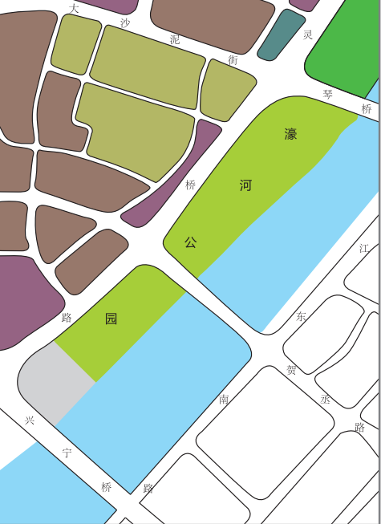
Xingning Bridge
Dashani St
Lingqiao Rd
Aixin Park

Annex 2：Layout plan of the park
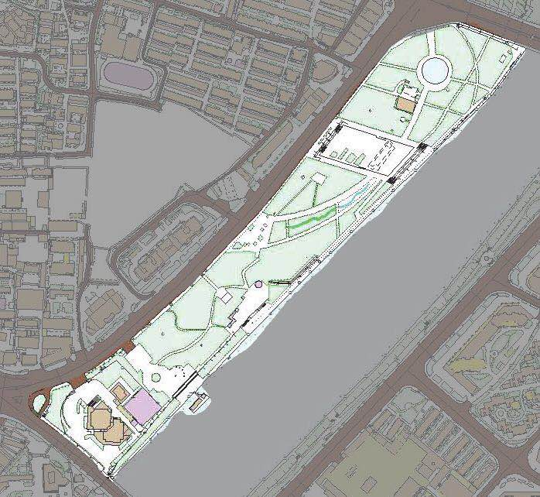

Annex 3：Map of the designated place for sculpture and pictures of the installation platform

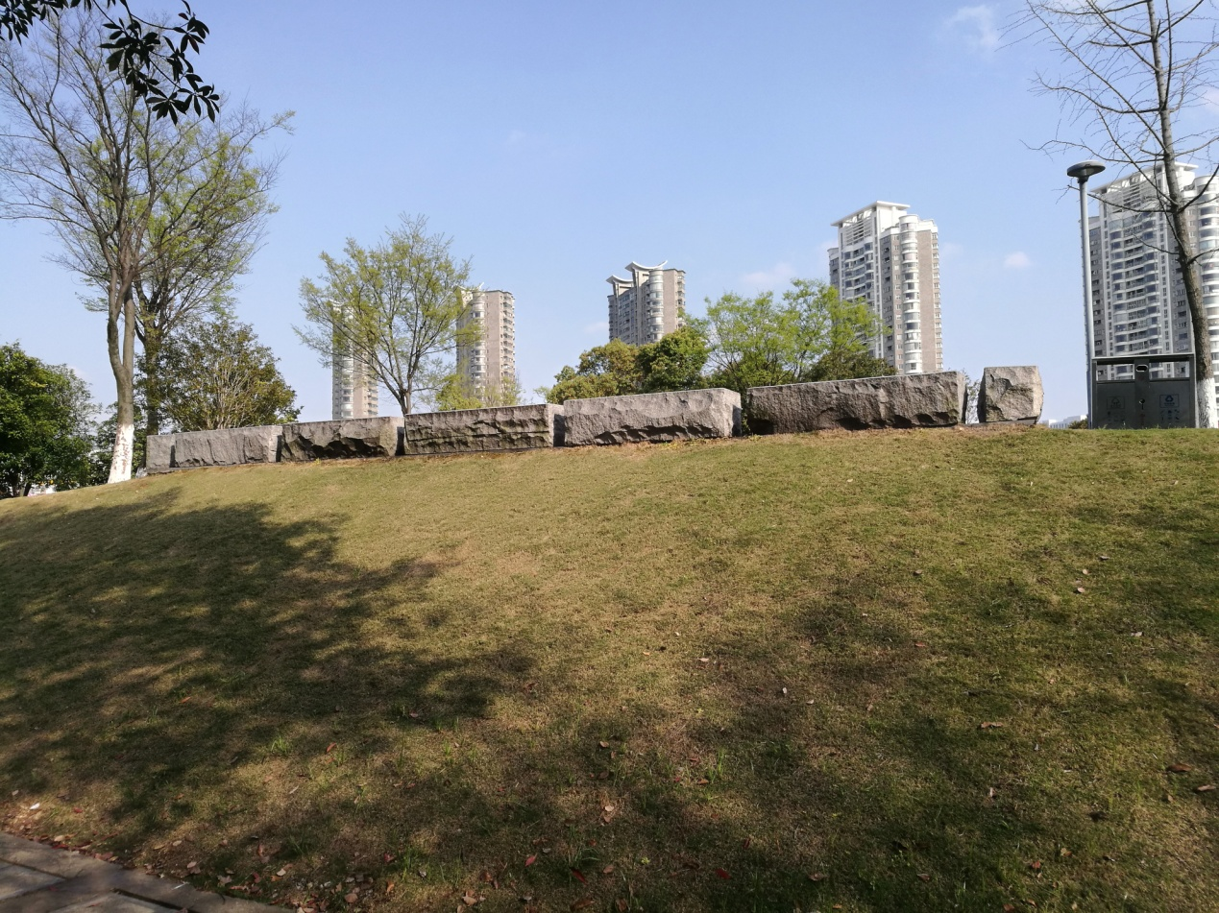
View of the platform from the west

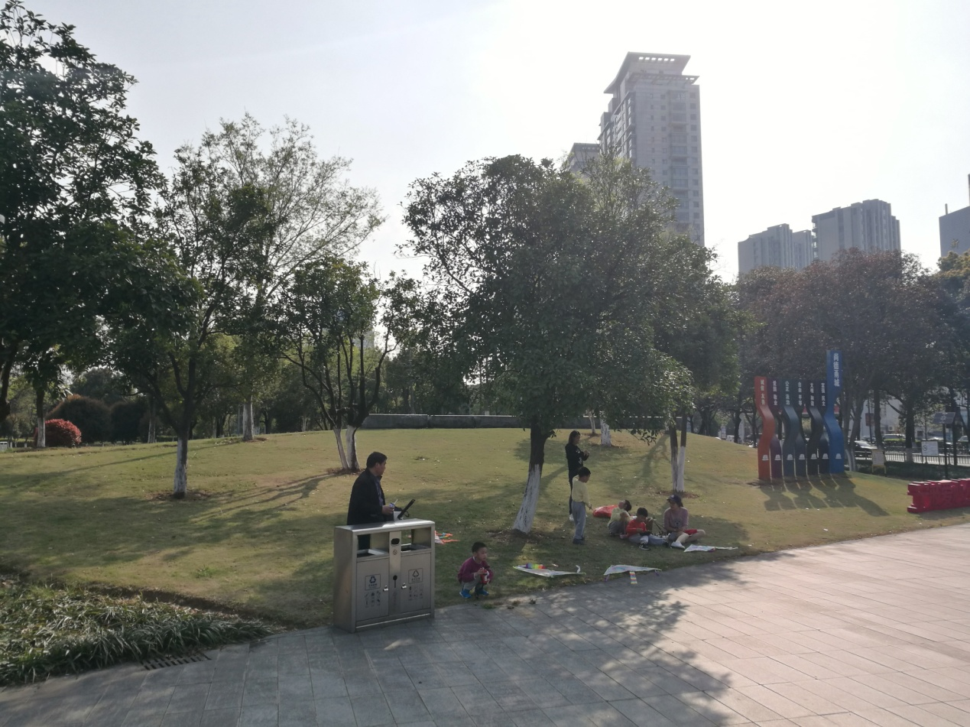
View of the platform from the northeast
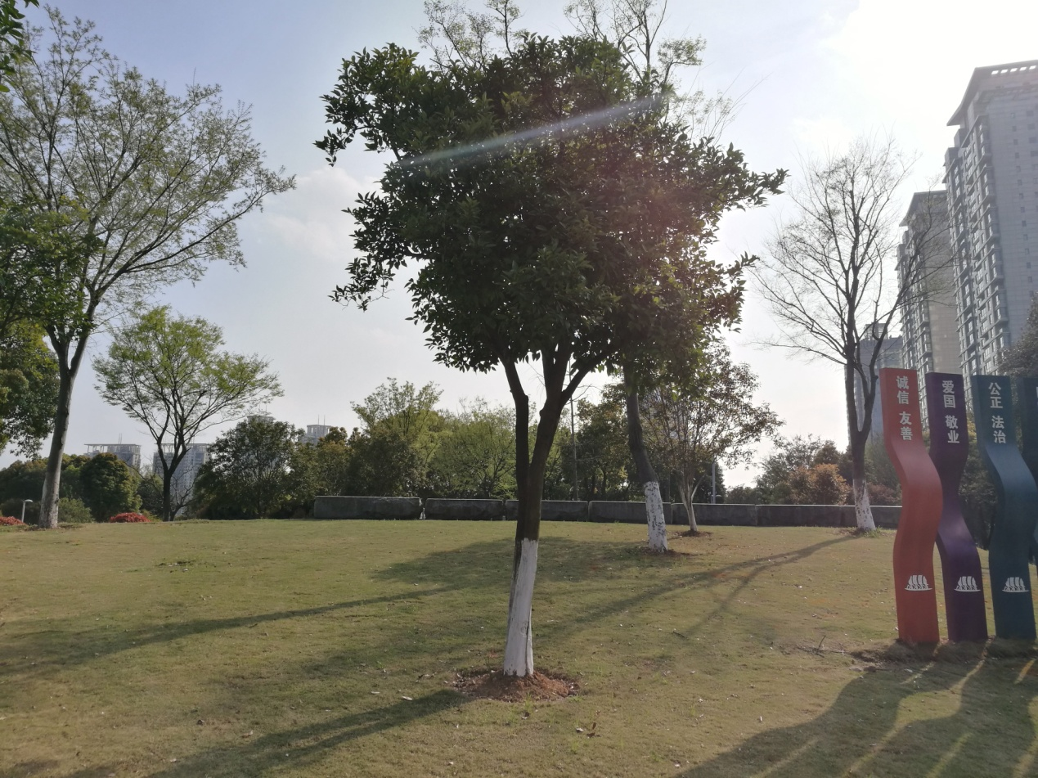
View of the platform from the north

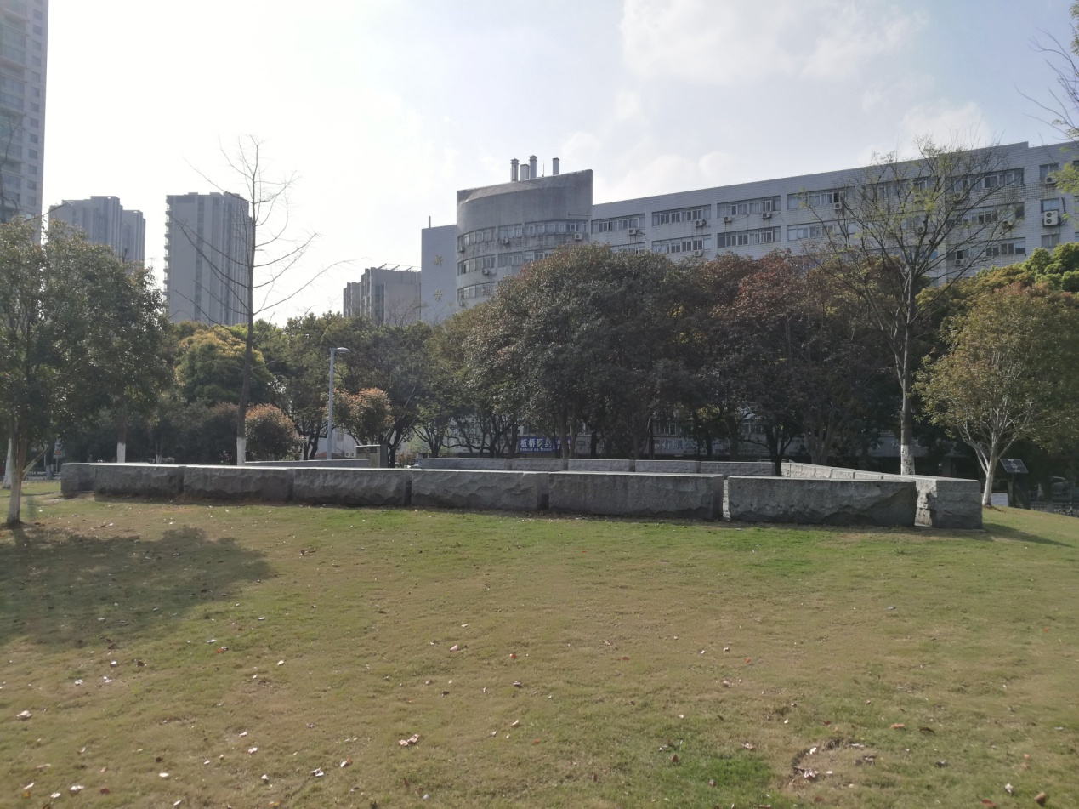
View of the platform from the east
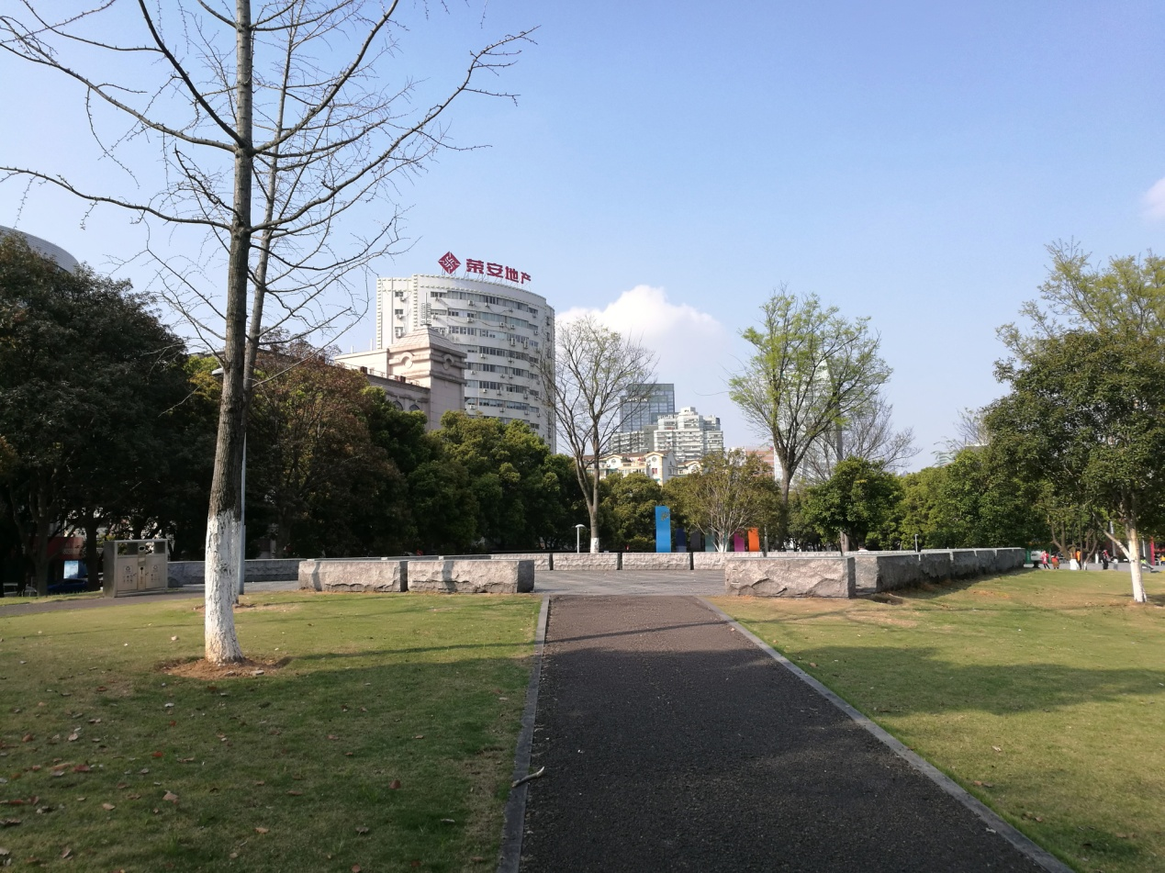
View of the platform from the south 1

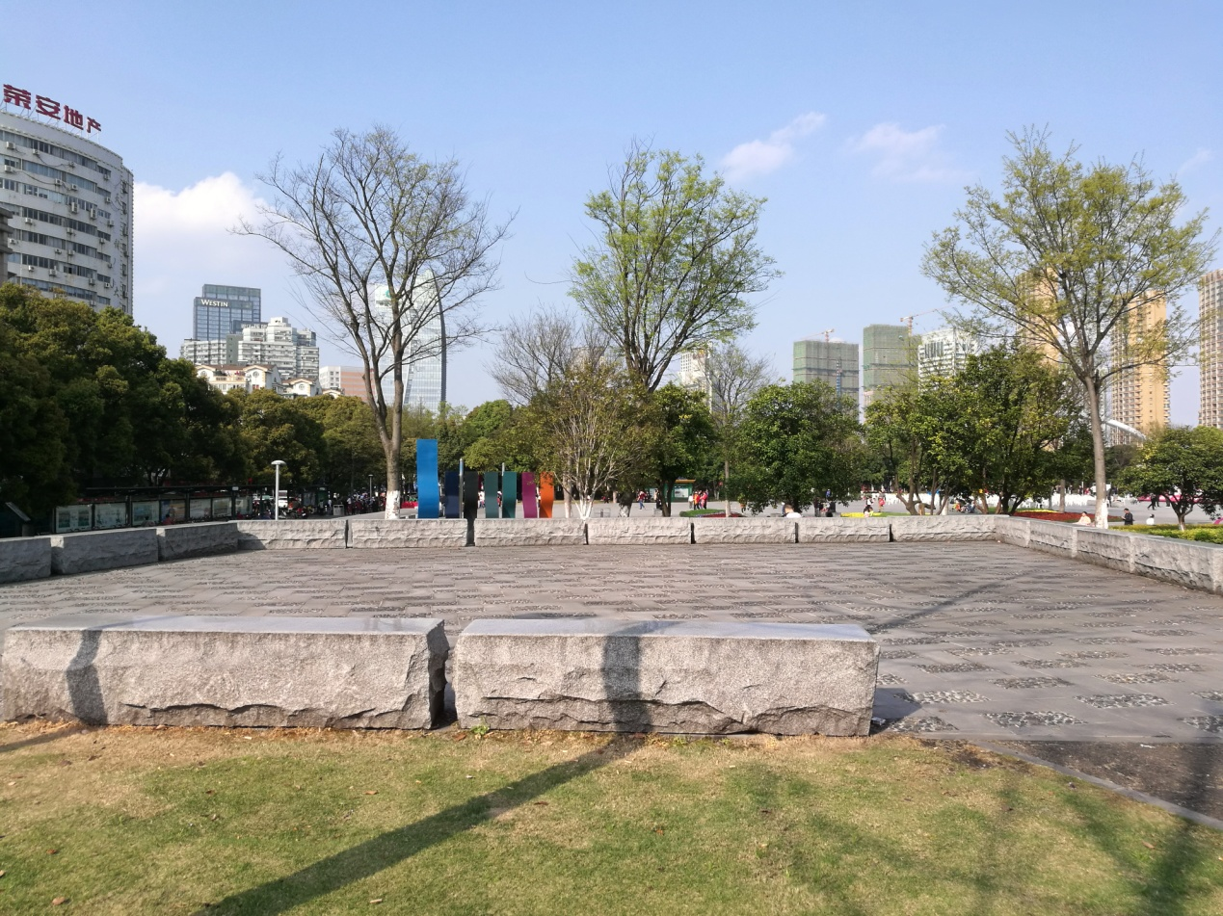
View of the platform from the south 2

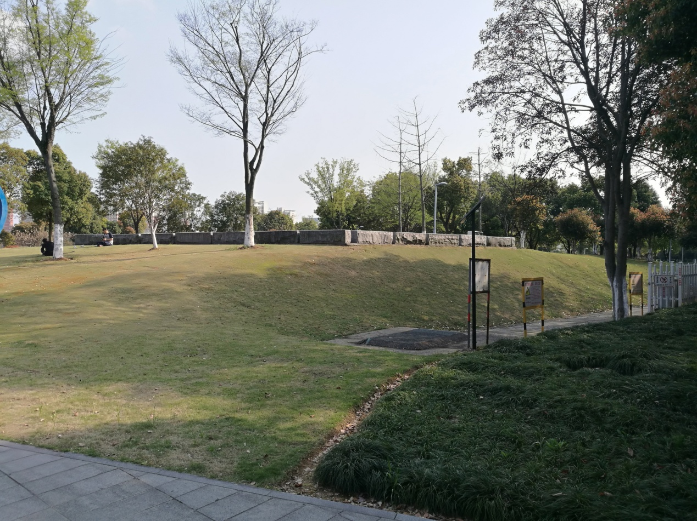
View of the platform from the northwest

Annex 4
Registration Form
Name |  |  |  | Sex |  | Age |  | E-mail
Mobile Number |  |  |  |  |  | Organization
Address
Artwork Description (attach additional pages when necessary) | Sculpture Name
Com-ments
Note: 1. Submitted materials will not be returned, please keep a copy for future reference.
2. All blanks should be filled in except for the Comments section.
3. Submitted materials should be originally developed or created. No plagiarism. IPR of submitted materials should be fully owned by the submitter. If any disputes should occur related to IPR, the submitting party is punishable by law.
4. The organizer is hereby authorized to use the submitted materials for event publicity and thus the submitting party will not receive remuneration for event publications.

